Smart Public Restroom
Submitted by : M.Khaja Mohiddin
Reg.no : au723921106007
E-mail I’d : khajamohiddin409@gmail.com
INNOVATION :
A smart public restroom refers to a technologically advanced and well-equipped public toilet facility that integrates various technologies and innovations to improve user experience, hygiene, and resource efficiency. These smart restrooms are designed to provide a higher level of convenience, cleanliness, and sustainability.
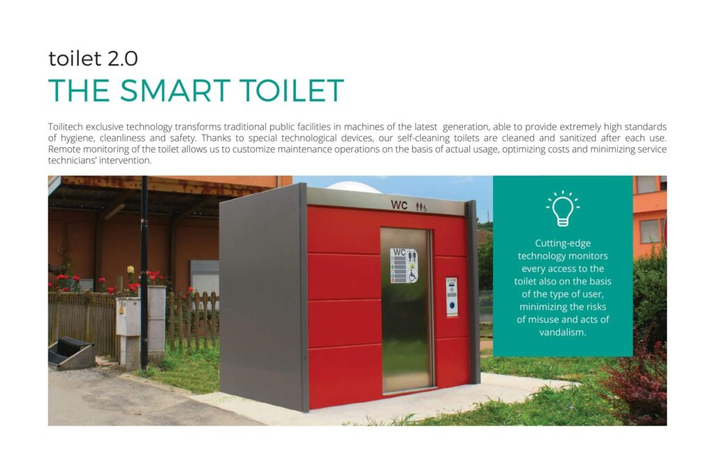
What are the problems faced by the people in the public smart restroom ?
- Technical Malfunctions: Smart restroom equipment can experience technical issues, such as sensor malfunctions or system failures, leading to inconvenience and discomfort for users.
- Complexity: The advanced features and technology in smart restrooms may confuse some users, especially those who are not familiar with touchless fixtures or other high-tech elements.
- Privacy Concerns: Users may have concerns about the privacy implications of sensors and cameras used for monitoring and maintenance purposes. Ensuring privacy while maintaining security is a delicate balance.
- Maintenance Delays: When smart restrooms require maintenance or cleaning, delays in response can result in unhygienic conditions or out-of-service facilities.
- Lack of Maintenance: In some cases, the high-tech components may not be adequately maintained, leading to suboptimal performance, reduced hygiene, and functionality issues.
- Inadequate Accessibility: Not all smart restrooms are designed with accessibility in mind, which can be problematic for users with disabilities who require features like wheelchair-accessible stalls or braille signage.
- Dependency on Electricity: Smart restrooms rely on electricity to power sensors, lighting, and other features. Power outages can render some features nonfunctional, causing inconvenience.
- Limited Water Availability: In areas with water scarcity, smart restrooms that offer automatic flush toilets and sensor-activated faucets may not be sustainable.
- Maintenance Costs: Smart restroom facilities can be more expensive to build and maintain due to the technological components, and funding for upkeep may not always be available.
- Reliability: Users may encounter inconsistencies in the performance of touchless fixtures and sensors, leading to frustration or confusion.
Why public smart restrooms are provided in the society ?
Public smart restrooms are provided in society for a variety of reasons, each of which contributes to improving the overall quality of life, promoting public health, and enhancing the urban environment. Here are some of the primary reasons why public smart restrooms are installed in society:
- Enhanced Hygiene: Smart restrooms often feature touchless fixtures, such as automatic flush toilets, sensor-activated faucets, soap dispensers, and hand dryers. These elements minimize the need for physical contact, reducing the spread of germs and promoting better hygiene.
- Improved Cleanliness: Many smart restrooms are equipped with automated cleaning and maintenance systems, which help ensure that the facility remains clean and well-maintained at all times. Regular cleaning schedules can be optimized based on real-time data.
- Resource Efficiency: Smart restrooms prioritize resource efficiency by incorporating features like low-flow toilets and water-saving faucets to reduce water usage. Energy-efficient lighting and HVAC systems also contribute to sustainability.
- Public Health: Access to clean and well-maintained public restrooms is crucial for public health. Adequate restroom facilities encourage proper sanitation and reduce the likelihood of open defecation or public urination, which can lead to environmental and health problems.
- Convenience for the Public: Smart restrooms are often strategically located in high-traffic areas, such as urban centers, transportation hubs, and tourist destinations. They provide a convenient and accessible place for people to relieve themselves, making urban life more comfortable.
- Accessibility: Smart public restrooms are designed with accessibility in mind, offering features such as wheelchair-accessible stalls, braille signage, and audio announcements for visually impaired users, ensuring that they are accessible to all individuals.
- Sustainability: Some smart restrooms incorporate sustainability measures like rainwater harvesting, green building materials, and energy-efficient technologies, reducing their environmental impact and contributing to a more sustainable urban environment.
- Real-Time Monitoring: Advanced sensor systems and cameras can provide real-time data on restroom usage, occupancy, and maintenance needs. This information helps facility managers optimize resources and respond quickly to issues.
- Safety: Public restrooms can include safety features such as surveillance cameras and emergency buttons, providing a secure environment for users.
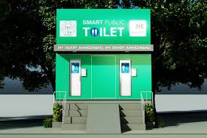
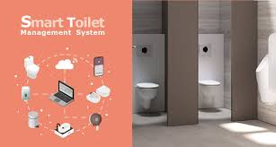

In conclusion, smart public restrooms represent a forward-thinking approach to addressing the needs of modern urban societies. These facilities, equipped with advanced technology and innovative features, offer a range of benefits and solutions to enhance public health, convenience, and sustainability.

